[INSERT STATE] TRIO FACTBOOK TEMPLATE

Dear TRIO State Leaders,
This document is a template with ideas to help create or improve your state TRIO fact book. You can share your state fact book with elected officials at COE’s Legislative Conference and all year round. You can download and customize this document for your state, add student/alumni photos and profiles, include state and congressional district-level TRIO information, and your state leadership contacts. For each section, you can view screenshots from exemplary TRIO state fact books from around the country, and at the end is a chart with all TRIO state fact books and TRIO state association websites to share additional ideas.
Council for Opportunity in Education
2021-2022
[Cover page] Use an actual photo of students from your state, and include your State TRIO Association Logo
TABLE OF CONTENTS
INTRODUCTION | Pg. 2
[INSERT STATE] TRIO PROGRAMS | Pg. 3
[INSERT STATE] TRIO PROGRAMS DATA | Pg. 5
MAP OF TRIO PROGRAMS IN [INSERT STATE] | Pg. 6
TRIO BY CONGRESSIONAL DISTRICT | Pg. 7
[INSERT STATE] TRIO STUDENT and Alumni STORIES | Pg. 8
[INSERT STATE] TRIO Association Leaders | Pg. 10
Examples from other State factbooks | Pg. 11
Links to other STATEs and contacts | Pg. 18

[INSERT STATE] TRIO ASSOCIATION
WHAT IS TRIO?
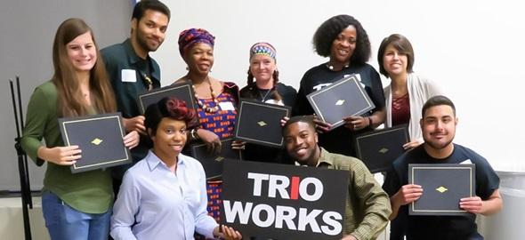
(PERSONALIZE IMAGE(S)/COULD USE MULTIPLE)

Here, give an overview of TRIO and its goals nationally and in your state. Why does TRIO exist?
How does TRIO help on a nationwide level and in your state?

EXAMPLE:
TRIO is a network of federally supported college opportunity programs that encourage and support students from disadvantaged backgrounds to pursue a college education. Over 3,100 programs nationwide assist more than 800,000 low-income, first-generation students and students with disabilities, from sixth grade through college graduation. TRIO programs offer academic tutoring, personal counseling, mentorship, financial guidance, and other services to aid students in educational access and retention.

TRIO programs were the first national college access and retention initiatives in the United States to address severe social and cultural hurdles to learning. TRIO was established as part of Lyndon B. Johnson's War on Poverty. Upward Bound was developed by the Educational Opportunity Act of 1964 as an experimental program. The Higher Education Act of 1965 then established Talent Search. Finally, in 1968, the Special Services for Disadvantaged Students (later known as Student Support Services) project was introduced. This "trio" of federally funded initiatives helped low-income students gain entry to higher education. Educational Opportunity Centers and Veterans Upward Bound were added in 1972, the Ronald E. McNair Post-Baccalaureate Achievement Program in 1986, and Upward Bound Math/Science in 1990.

Two-thirds of the students served by each program must come from homes with earnings of 150 percent or less of the federal poverty threshold, with neither parent having completed college, as stipulated by Congress. More than 1,000 colleges, universities, community colleges, and agencies now offer TRIO Programs in the U.S. and its territories. TRIO funds are distributed to institutions and agencies through competitive 5-year grants.

[INSERT STATE] TRIO PROGRAMS

DESCRIBE WHAT EACH APPLICABLE PROGRAM DOES & WHO IT SERVES (Ages/grade-levels) BE SURE TO TOUCH ON THE GOALS OF EACH PROGRAM For a national fact sheet on each program, click here.

UPWARD BOUND (UB)
Population Served:
Students in grades 9-12 who qualify as low-income or potentially first-generation college students.

Services Offered:
Academic year weekly services and a six-week summer program. Services include academic instruction in math, science, composition, literature, and foreign language, tutoring and mentoring, academic, financial, and personal counseling, assistance completing college & financial aid applications, and career exploration.

UPWARD BOUND MATH & SCIENCE
Population Served:
Students in grades 9-12 who qualify as low-income or potential first-generation college students who have an interest in pursuing careers in STEM.

Services Offered:
Summer programs consist of intensive math and science training, year-round counseling and advising, computer training, exposure to university faculty who perform research in math and science, scientific research conducted under the guidance of a faculty or graduate student mentor. Tutoring and mentoring, academic, financial, and personal counseling, assistance completing college and financial aid applications, and career exploration.

VETERANS UPWARD BOUND
Population Served:
Veterans who meet military service requirements stipulated in the authorizing statute and who are low-income, prospective first-generation college students preparing to enter a postsecondary institution.

Services Offered:
Intensive basic skills development for GED completion, refresher classes for subjects required in college, academic, financial, and personal counseling, tutoring services, and assistance completing college and financial aid applications.

[INSERT STATE] TRIO PROGRAMS

EDUCATIONAL OPPORTUNITY CENTERS
Population Served:
Adults 19 years or older pursuing postsecondary education as first-generation and low-income students.

Services Offered:
Academic advising, personal counseling, career workshops, college application assistance & test preparation, and financial & economic literacy education.

MCNAIR SCHOLARS PROGRAM
Population Served:
Undergraduate students who qualify as low-income, first-generation, and/or underrepresented populations in their field of interest who wish to pursue graduate education.

Services Offered:
Opportunities for mentorship & scholarly activities, summer research internship, seminars & workshops to prepare students for graduate study, and assistance with graduate school admissions processes.

STUDENT SUPPORT SERVICES
Population Served:
Undergraduate students who are low-income, prospective first-generation college students or students with disabilities.

Services Offered:
Intensive academic, financial, and personal counseling, tutoring services, and assistance completing college and financial aid applications.

TALENT SEARCH
Population Served:
Students in grades 6-12 and adults up to age 27 pursuing post-secondary education who qualify as low-income or potential first-generation college students.

Services Offered:
Academic, financial, and career counseling, exposure to college campuses, tutoring services, assistance in completing the college admissions process, and publicizing and assisting with financial aid applications.

[INSERT STATE] TRIO PROGRAM DATA
(20XX-20XX)
Try to compile statewide statistics from your programs, if possible. You can use the data each program already provides for the Annual Performance Reports.

Educational Talent Search
Total Students | X
Low-Income & First-Generation Students (LIFG) | X
Rate of Non-Senior Students Persisting to the Next Grade Level | X%
Rate of Seniors Completing FAFSA | X%
Rate of Seniors Graduating with Rigorous Curriculum | X%
High School Graduation Rate | X%
College Enrollment Rate | X%

Educational Opportunity Centers
Total Students | X
Low-Income & First-Generation Students (LIFG) | X
Rate of Students Completing FAFSA | X%
Rate of Students Applying for College | X%
Rate of Students Enrolling in College | X%

Upward Bound
Total Students | X
Low-Income & First-Generation Students (LIFG) | X
Benchmark Completion Rate | X%
Rate of Seniors Graduating with Rigorous Curriculum | X%
High School Graduation Rate | X%
College Enrollment Rate | X%
Rate of 2013-14 Cohort College Enrollees Graduating in 6 years | X%

McNair
Total Students | X
Low-Income & First-Generation Students (LIFG) | X
Rate of Students Completing Research/ Other Scholarly Activities | X%
Graduate School Enrollment Rate | X%
Continued Enrollment in Graduate School Rate | X%
Doctoral Degree Attainment | X%

Student Support Services
Total Students | X
Low-Income & First-Generation Students (LIFG) | X%
College Retention Rate | X%
Graduation Rate | X%
Graduates Transferring | X

MAP OF Illinois TRIO PROGRAMS
Map of Illinois TRIO projects by congressional district, program year 2020-21

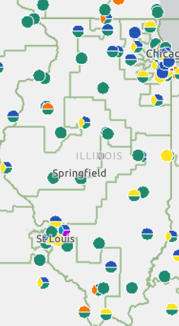
Source: U.S. Department of Education, TRIO Project Explorer (Program Year 2020-21)

[INSERT STATE] TRIO PROGRAMS BY DISTRICT
Include a chart listing the TRIO programs in each congressional district, including the number of students served and annual funding.

Note: For COE’s 2022 Legislative Conference, please use the latest FY21 data. COE will provide an update once ED releases the FY21 slates. As a past example, TRIO data for FY20 is here.

CONGRESSIONAL DISTRICT | INSTITUTION | PROGRAM | # OF STUDENTS | FY 20XX FUNDING
1 | X | X | X | X
2 | X | X | X | X
3 | X | X | X | X
4 | X | X | X | X
5 | X | X | X | X
6 | X | X | X | X
7 | X | X | X | X
8 | X | X | X | X
9 | X | X | X | X
10 | X | X | X | X
 | X TOTAL | X PROGRAMS | X STUDENTS | $ XXX, XXX

[INSERT STATE] TRIO STUDENT AND ALUMNI STORIES
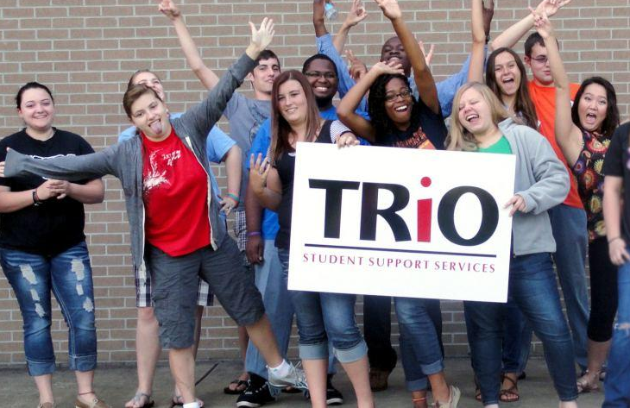
INCLUDE PERSONALIZED IMAGES FROM TRIO PROGRAMS, STUDENTS, AND ALUMNI

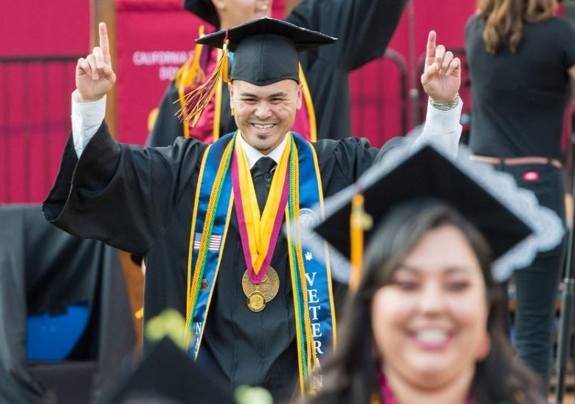

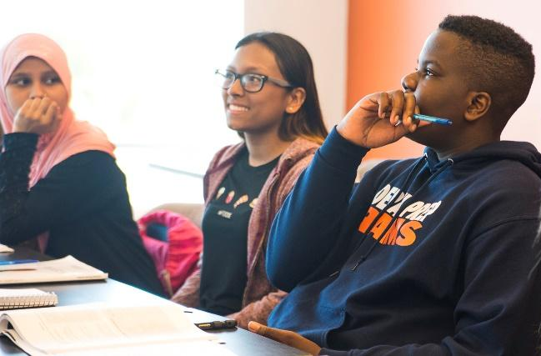

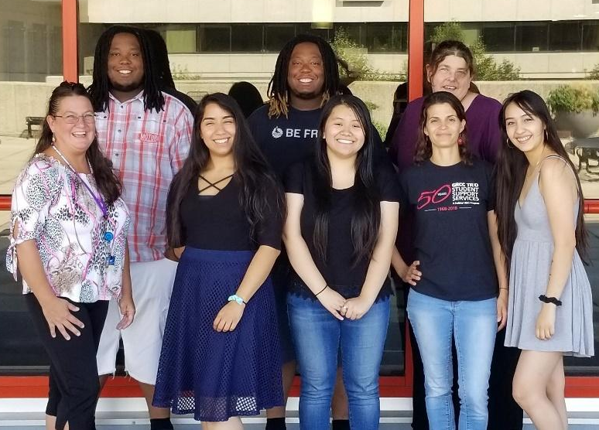

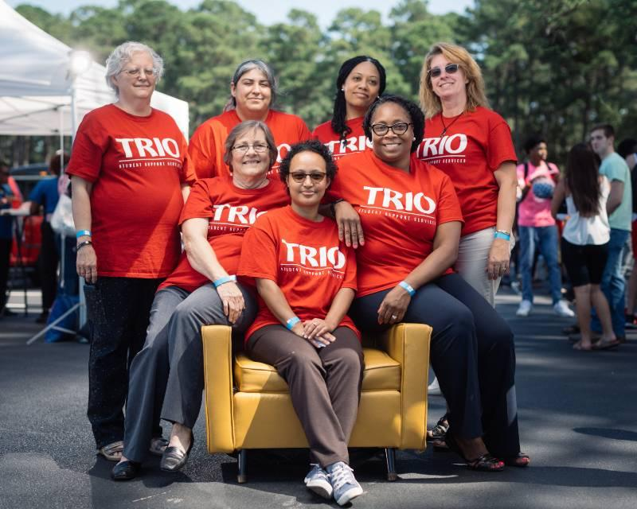

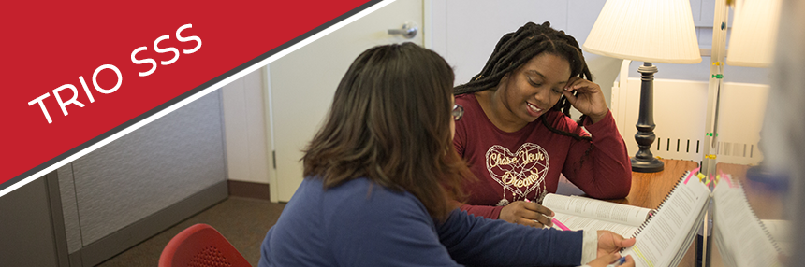

[INSERT STATE] TRIO STUDENT AND ALUMNI STORIES
Include student/alumni photos and brief stories or quotes, ideally with at least one per district. Include students from a variety of TRIO programs and geographical areas.

District X (if you have at least one story per district, or else statewide…)


XAVIER JOHNSON – COMMUNICATIONS
Florida State University: TRIO McNair
“TRIO McNair has been a great support system emotionally and physically. TRIO McNair has been a great part of my college experience. I am hard of hearing, so some things are not always easy. I am a proud TRIO member, and they are always there for me when I need assistance.”


XAVIER JOHNSON – COMMUNICATIONS
Florida State University: TRIO McNair
“TRIO McNair has been a great support system emotionally and physically. TRIO McNair has been a great part of my college experience. I am hard of hearing, so some things are not always easy. I am a proud TRIO member, and they are always there for me when I need assistance.”


STUDENT NAME – AREA OF STUDY
Institution Name: TRIO program name
Include Student Story. Have students share their experiences with the TRIO Program. How has the TRIO program positively impacted the student? Include a variety of the program.

[INSERT STATE] TRIO ASSOCIATION BOARD OF DIRECTORS: CONTACT INFORMATION
TITLE | INSTITUTION | PROGRAM |  | EMAIL
President | X | X | X
Past President | X | X | X
Secretary | X | X | X
Treasurer | X | X | X
District 1 | X | X | X
District 2 | X | X | X
Technology Specialist | X | X | X
Alumni Relations Partner | X | X | X
Government Relations | X | X | X

EXAMPLES
Note: If possible, try to also add some benchmark data for other low-income students in the state, showing how TRIO has stronger results for key outcome measures.

Oregon TRIO Program Outcome Data!

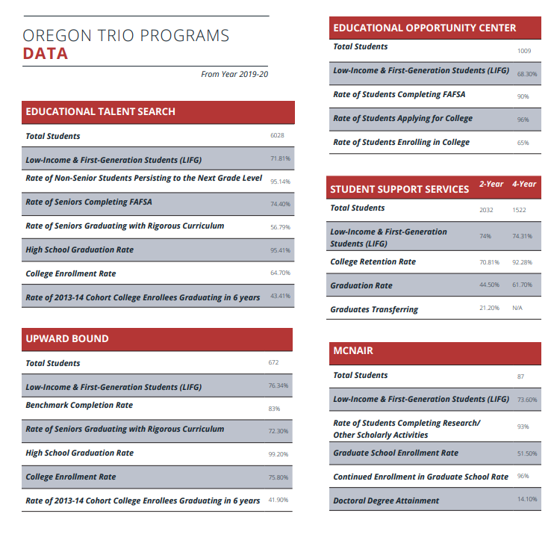

TRIO statewide outcome data from Idaho TRIO!
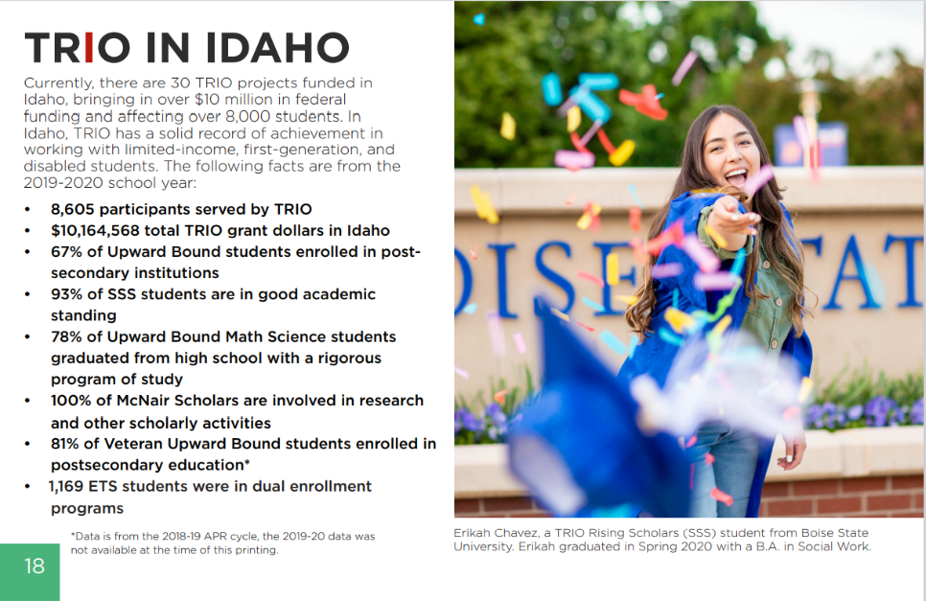

Data by institution from South Dakota TRIO!
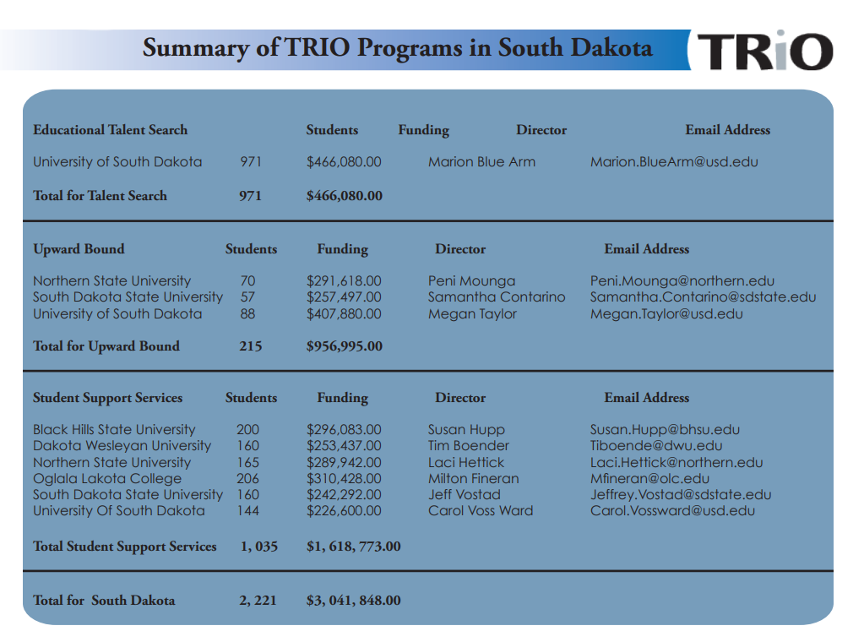

Student Stories separated by Congressional District from Wisconsin TRIO!
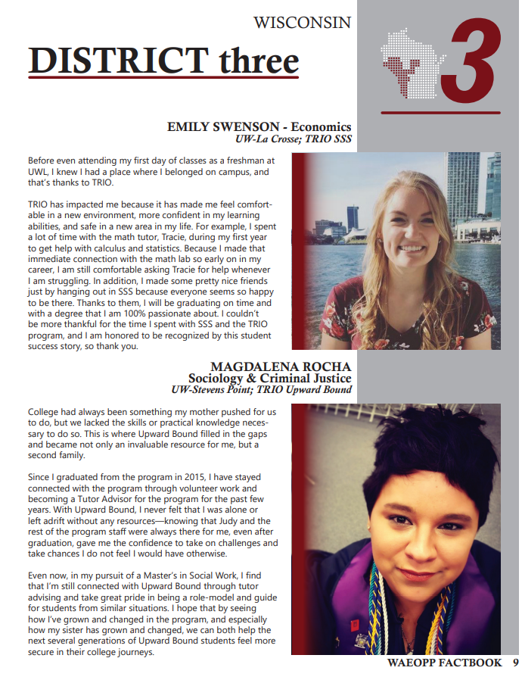

Example of a map showing all TRIO programs by congressional district from Indiana TRIO!

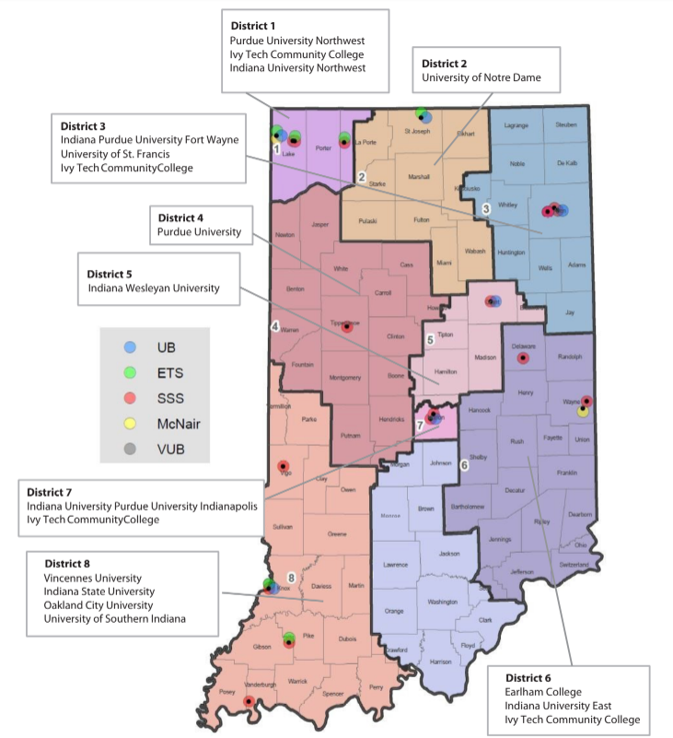

Example from New York State with a map and chart of TRIO programs for greater NYC region

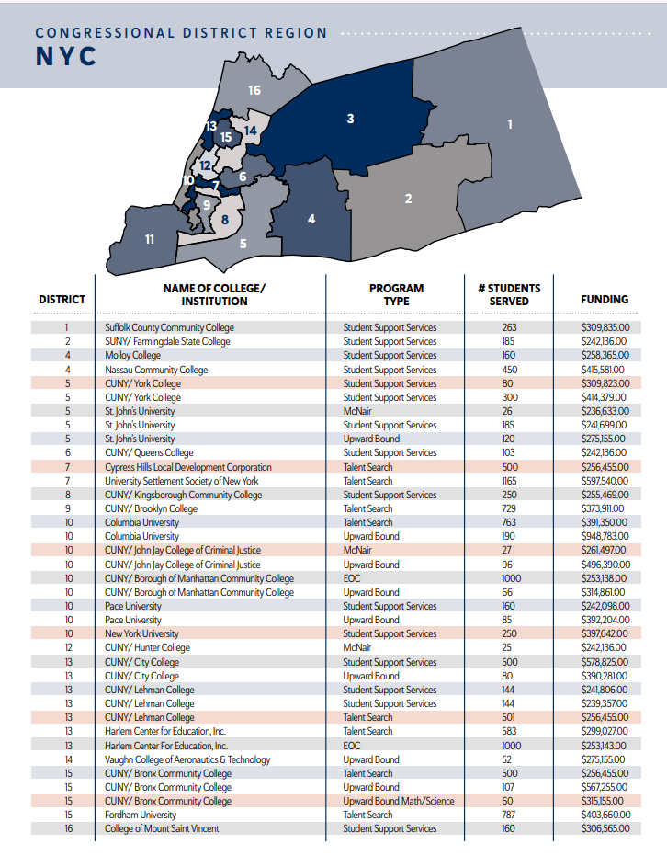
Example from New York State on Individual District Data

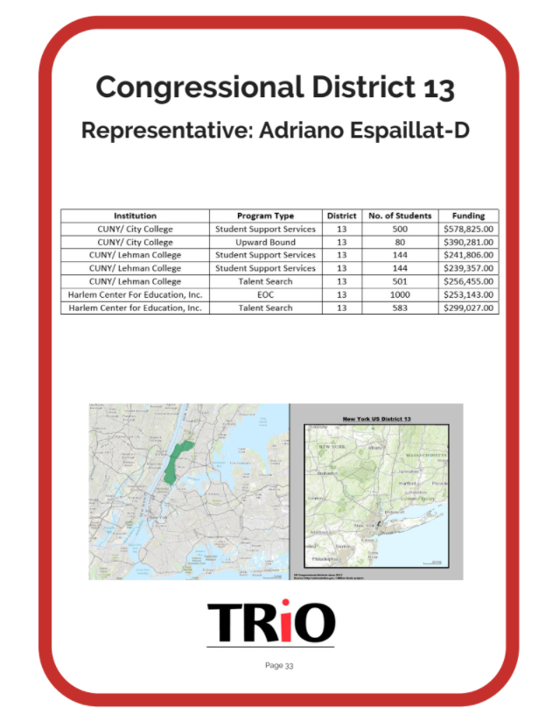

DIRECTORY OF TRIO STATE ASSOCIATION WEBSITES, ONLINE STATE FACTBOOKS, AND TRIO STATE LEADERS
***Are we missing your most recent fact book, website, or state president’s info? Please share the link to your latest version in this google form here. Is the State Leader out of date? Contact Jennifer.Rudolph@coenet.org

State | State Website | State Factbook | TRIO State Leader |  | State Leader Email
AK | Alaska Website | Alaska Factbook | Jessica Delgado |  | jpdelgado@alaska.edu
AL | Alabama Website | N/A | Cody Hammack |  | cody.hammack@bscc.edu
AR | Arkansas Website | Arkansas Factbook | Desarae Nelson |  | dxnelson1@ualr.edu
AZ | Arizona Website | Arizona Factbook | Nilda Iniguez |  | nilda.iniguez@asu.edu
CA-C | Central California Website | California Factbook | Mike Osorio |  | michael.osorio@evc.edu
CA-S | Southern California Website | California Factbook | Horacio Aceves |  | socalchapterpres@westop.org
CA-N | Northern California Website | California Factbook | Keyanna Hatcher |  | norcalchapterpres@westop.org
CO | Colorado Website | Colorado Factbook | Dariana Roybal |  | dariana.roybal@csupueblo.edu
CT | Connecticut Website | N/A | Rob Pote |  | poter@wcsu.edu
DC | DC Website | N/A | Janeale Gottlieb-George |  | jggeorge@gwu.edu
DE | Delaware Website | N/A | Da’Shon Jones |  | djone188@dtcc.edu
FL | Florida Website | N/A | Rowina Petion |  | harmonr@palmbeachstate.edu
GA | Georgia Website | Georgia Factbook | Sonia Davis |  | sdbrad@uga.edu
HI | Hawaii Website | N/A | James Oda |  | James.Oda@gmail.com
IA | Iowa Website | N/A | Jodi Kremer |  | kremerj9@nicc.edu
ID | Idaho Website | Idaho Factbook | Arielle Horan |  | ahoran@uidaho.edu
IL | Illinois Website | Illinois Factbook | Lolita Mack |  | lmack@eoa.org
IN | Indiana Website | Indiana Factbook | Melida Chen |  | gutimeli@iupui.edu
KY | Kentucky Website | N/A | Stephen Keene |  | stephen@kytrio.org
KS | Kansas Website | Kansas Factbook | Kurt Petersen |  | kurt.peterson@gcccks.edu
LA | Louisiana Website | N/A | Jamie Flanagan |  | flanagan@nsula.edu
MA | Massachusetts Website | Massachusetts Factbook | Kristen Wing |  | kwing@valleyopp.com
MD | Maryland Website | Maryland Factbook | Matthias Seisay |  | mseisay@bowiestate.edu
ME | Maine Website | Maine Factbook | Sam Prosser |  | samantha.prosser@maine.edu
MI | Michigan Website | N/A | Andrea Mireles |  | micapp-president@eoa.org
MN | Minnesota Website | N/A | Michael Bro |  | michael.bro@minneapolis.edu
MO | Missouri Website | Missouri Factbook | Beth Jacobson |  | beth.jacobson@unl.edu
MS | Mississippi Website | N/A | Kimberly Bee |  | ksbee@coahomacc.edu
MT | Montana Website | Montana Factbook | Peter Donaldson |  | peter.donaldson@mso.umt.edu
NC | North Carolina Website | N/A | Maurice Mathis |  | mamathi2@ncsu.edu
ND | North Dakota Website | N/A | Cathleen Ruch |  | cathleen.ruch@lrsc.edu
NE | Nebraska Website | Nebraska Factbook | Krystal Rice |  | Krystal.rice@creighton.edu
NH | New Hampshire Website | N/A | Adam Howard |  | Adam.howard@unh.edu
NJ | New Jersey Website | N/A | Jakasha Wiley |  | jackasha.wiley@rutgers.edu
NM | New Mexico Website | N/A | Jesus Villarreal |  | jvillarreal@lnesc.org
NV | Nevada Website | N/A | Lakiasha Hollingsworth |  | nvchapterpres@westop.org
NY | New York Website | N/A | Yuri Job |  | YuriJob@ccny.cuny.edu
OH | Ohio Website | N/A | Zyanya Torres |  | zyanyastorres@gmail.com
OK | Oklahoma Website | N/A | John Thao |  | john.thao@tulsacc.edu
OR | Oregon Website | Oregon Factbook | Christine Riehl |  | criehl@clatsopcc.edu
PA | Pennsylvania Website | N/A | Eron McMillen |  | mcmillen_e@calu.edu
PR | Puerto Rico Website | N/A | Fabiola Falto |  | ffalto@uaa.edu
RI | Rhode Island Website | N/A | Gail Mance-Rios |  | gemancerios@ccri.edu
SC | South Carolina Website | N/A | Ashley Robinson |  | robinsonag@cofc.edu
SD | South Dakota Website | South Dakota Factbook | Jennie Thompson |  | jennie.Thompson@northern.edu
TN | Tennessee Website | N/A | Melissa Towe |  | melissa.towe@mtsu.edu
TX | Texas Website | Texas Factbook | Fidel Zapata |  | Fidelz@exchange.uta.edu
UT | Utah Website | Utah Factbook | Samantha Hill |  | samanthahill2@weber.edu
VA | Virginia Website | N/A | Sharon Harris |  | sharon.harris@danville.edu
VT | Vermont Website | Vermont Factbook | Lindsay Carpenter |  | carpenter@vsac.org
WA | Washington Website | Washington Factbook | Dina Ibarra |  | dibarra@uw.edu
WI | Wisconsin Website | Wisconsin Factbook | Melissa Luedtke |  | mjluedtke22@marianuniversity.edu
WV | West Virginia Website | West Virginia Factbook | Chelsea Toms |  | tomsc@dewv.edu
WY | Wyoming Website | N/A | Teffany Fegler |  | tfegler@wyoming.com

